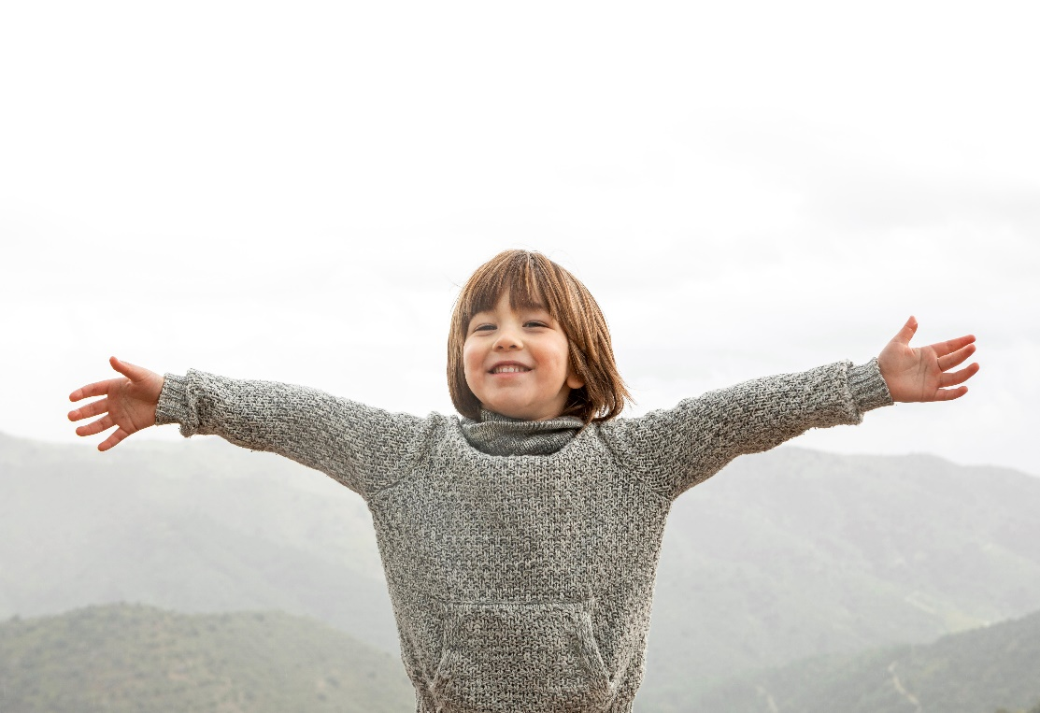
How to Teach Children Gratitude
(The following article can be found at www.verywellmind.com)

Teaching kids to say thank you is an important social skill that many parents stress, but helping them understand how to be truly grateful is a bit trickier. In a time when many middle school kids carry around $600 phones that they take for granted, teaching gratitude can feel like an uphill battle.
Despite the challenges you might face in helping kids feel grateful in a world that seems to value overabundance, it can be worthwhile.
Teaching children gratitude can help them feel happier, support better social relationships, and improve overall health and well-being. Strategies that can help foster gratitude in kids include asking gratitude-focused questions, performing acts of kindness, and modelling gratitude in your own life. Let's explore how kids can benefit from gratitude and some strategies that help kids learn to be more grateful.
Gratitude can have many benefits for adults, but research has shown how it can also help kids in various ways.
Grateful Kids Are Happier
A 2019 study published in the Journal of Happiness Studies found that gratitude is linked to happiness in children by age 5.¹ This means that instilling gratitude in your kids at a young age could help them grow up to be happier people.
One older study found that grateful children (ages 11 to 13) are happier, more optimistic, and have better social support.² They also report more satisfaction with their schools, families, communities, friends, and themselves. Grateful kids also tend to give more social support to others as well.
Grateful Teens Have Higher Life Satisfaction
According to a study published in Psychological Assessment, grateful teens (ages 14 to 19) are more satisfied with their lives, use their strengths to improve their communities, are more engaged in their schoolwork and hobbies, and have better grades.³ They’ve also been shown to be less envious, depressed, and materialistic than their less grateful counterparts.
Grateful Kids Are Healthier
It’s true that much of the gratitude research focuses on adults, but the benefits of gratitude are numerous for everyone. A study published in Clinical Psychology Review linked gratitude to everything from improved psychological well-being to better physical health.⁴ Grateful people tend to sleep better and even live longer.
Grateful Kids May Turn Into Grateful Adults
A 2018 study published in the Journal of Positive Psychology found that grateful adults are happier and more hopeful.⁵ Gratitude better-predicted hope and happiness than other constructs, like forgiveness, patience, and even self-control.
Additionally, the study found that people who were grateful for things that happened to them in the past felt happier in the present and more hopeful about their future. Perhaps giving your kids a childhood they feel grateful about now will help them reflect more on reasons to be grateful as adults.
So clearly, many good reasons exist to help kids experience and express gratitude. Here are a few strategies that can help your kids feel more grateful.
Teach Your Child to Say Thank You
Encourage your child to say "Thank you" regularly. Offer gentle reminders like, "Your brother let you go first. What should you say to him?" or "What do you say to Grandma for giving you a cookie?"
While it may seem like forcing a "thank you" doesn’t stir up any real gratitude, consider it a first step in the process. It can help kids start to recognize when others have given them something, whether tangible (like a gift) or intangible (like time).
So even if it doesn’t seem like genuine appreciation when your child needs a reminder, encouraging them to verbally express appreciation can be an important learning tool for genuine gratitude down the line.
You can also encourage your kids to write "thank you" notes to people who give them gifts or show them kindness. Your child might color a picture for a grandparent who purchased a birthday gift for them. Or you might encourage your teen to write a "thank you" letter to a special coach who has made an impact on their lives.
Make sure to point out times when your child shows gratitude without a prompt from you. Positive attention will reinforce the importance of showing gratitude.
Praise prosocial behaviour by saying things like, "I really like the way you thanked your friend for sharing with you today," or "Nice job remembering to say ‘thank you’ to your teacher when she reminded you to get your backpack."
Ask Gratitude Questions
Once your child remembers to say "thank you" on a regular basis, it can be time to dig a little deeper to ensure that they aren’t just going through the socially prescribed motions of saying "Thank you."
Start having conversations about what it means to be thankful, and take their understanding of gratitude to a whole new level by incorporating more gratitude components.
The Raising Grateful Children Project at UNC Chapel Hill has revealed that gratitude has four key parts:
- Noticing: Recognizing the things you have to be grateful for.
- Thinking: Thinking about why you’ve been given those things.
- Feeling: The emotions you experience due to the things you’ve been given.
- Doing: The way you express appreciation.
The researchers found that most parents focused on what children do to show gratitude. While 85% of parents said they prompted their kids to say "thank you," only 39% encouraged children to show gratitude in a way that went beyond good manners. In addition, only a third of parents asked their kids how a gift made them feel, and only 22% asked why they thought someone had given them a gift.⁶
Researchers from UNC encourage parents to ask kids questions to help foster a deeper sense of gratitude. Here are some questions that can help kids experience all four gratitude components:
- Notice: What do you have in your life to be grateful for? Are there things to be grateful for beyond the actual gifts someone has given you? Are you grateful for any people in your life?
- Think: What do you think about this present? Do you think you should give something to the person who gave it to you? Do you think you earned the gift? Do you think the person gave you a gift because they thought they had to or because they wanted to?
- Feel: Does it make you feel happy to get this gift? What does it feel like inside? What about this gift makes you feel happy?
- Do: Is there a way to show how you feel about this gift? Does your feeling about this gift make you want to share this feeling by giving to someone else?
Whenever your child receives a physical gift or someone shows kindness to them, strike up a conversation that helps them experience more gratitude. You also might start conversations that show how you both think, feel, and respond to the people and gifts you’re grateful for in your life.
Perform Acts of Kindness
There are many things your child can do to show appreciation for other people. This might involve returning a favor, like loaning a toy to a friend who is kind. Or it could involve an act of service like doing yard work for a relative who attends their basketball games.
Make it clear that there are many ways to show people that you’re grateful for all they do.
You might even decide to take on a family project, like writing thank you letters to the first responders in your community after a natural disaster. Make it clear that you don’t need to reserve gratitude for those individuals that you know personally—there are many people in the community whom you might feel grateful for as well.
Model Gratitude
A 2016 study published in Applied Developmental Science found that grateful parents tend to raise grateful children.⁷ There’s a good chance this is because kids learn to be grateful by hearing and seeing their parents experience gratitude.
Here are several ways you can model gratitude for your children:
- Say "Thank you.": Whether you thank the clerk at the store or you thank your child for clearing the table, make sure you’re thanking people often.
- Talk about gratitude: Make it a point to share what you’re grateful for. Even when you have a rough day or something bad happens, point out that there’s still a lot to feel grateful for. Instead of complaining about the rain, talk about being grateful that the plants are being watered so you’ll have food to eat.
- Express gratitude: When your child sees you writing “thank you” notes or sending a token of appreciation to someone, you’ll teach them to do the same.
Researchers have found that when parents engage in more daily socialization acts designed to target gratitude, children display higher levels of gratitude as well.⁸
Establish a Gratitude Ritual
Make it a habit to regularly express gratitude in your family. Here are some examples of rituals you might establish:
- Everyone takes turns during dinner sharing one thing they’re grateful for from their day.
- At bedtime, you ask each child to say three things they feel grateful for.
- During the car ride to school, everyone thanks someone else in the car for something.
- Each Sunday night at dinner, everyone discusses how they’ll express gratitude and who they’ll express it to over the course of the week.
- Every Saturday morning, everyone writes a note of appreciation to someone for a specific reason.
Although it might seem like gratitude should be spontaneous rather than rehearsed, making gratitude a habit can ensure that kids practice it on a regular basis, and it can become like second-nature.
Look for the Silver Lining
Help your kids see that something good can come from difficult circumstances. If a soccer game gets rescheduled due to rain, talk about the bright side of the situation. Say something like, "Well at least we don't have to be outside in the cold. We can play board games together instead and that will be fun."
You might also point out how to be grateful for what you had, even when it's no longer here. For example, you might say, "It's really sad our fish died but I'm grateful we got to have him for six months." Of course you don't want to sound uncaring and callous but you can make it clear that you can be both grateful and sad at the same time while honoring a loss.
Ask questions that help your child discover the potential silver lining in a tough situation. Ask, "What's something good that could come from something hard like this?"
In a really tough situation, asking that question too soon might seem insensitive (like 10 minutes after failing a test). So you might give it some time before encouraging your child to look on the bright side. But helping your child do this often, you'll teach them to begin doing it on their own and they'll start to see that they have a lot to be grateful for, even on their worst days.
Keep in Mind
Make gratitude a priority in your home. Not only will your child benefit, but the adults will likely get a much-needed boost in happiness and well-being also. Experiment with different strategies to help determine which gratitude practices help everyone best experience and express their grateful feelings.
Of course, there will be times when your kids seem to be ungrateful. This doesn’t mean you’ve failed in the gratitude department, however. It’s normal for kids to experience entitlement at times.
So turn these times into teachable moments. Work on new gratitude strategies and keep modelling how to be thankful, and you’ll likely see these moments of entitlement fade away.

