2014 Annual Report to
the School Community

  Harcourt Valley Primary School
  School Number: 5404
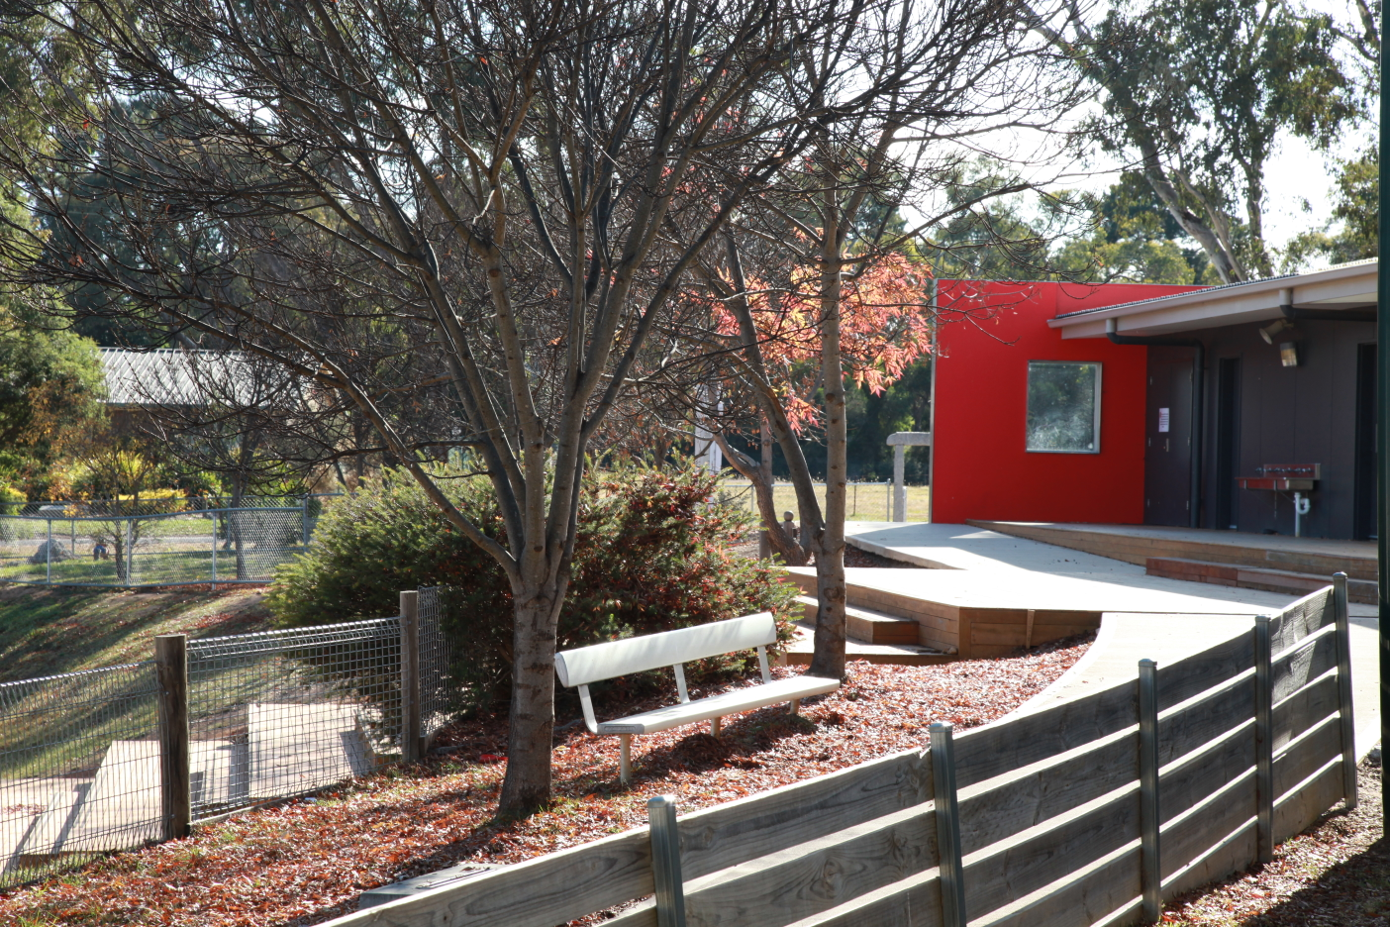 |  | 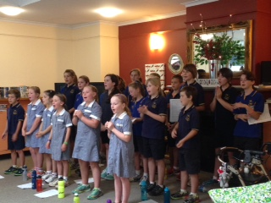 | 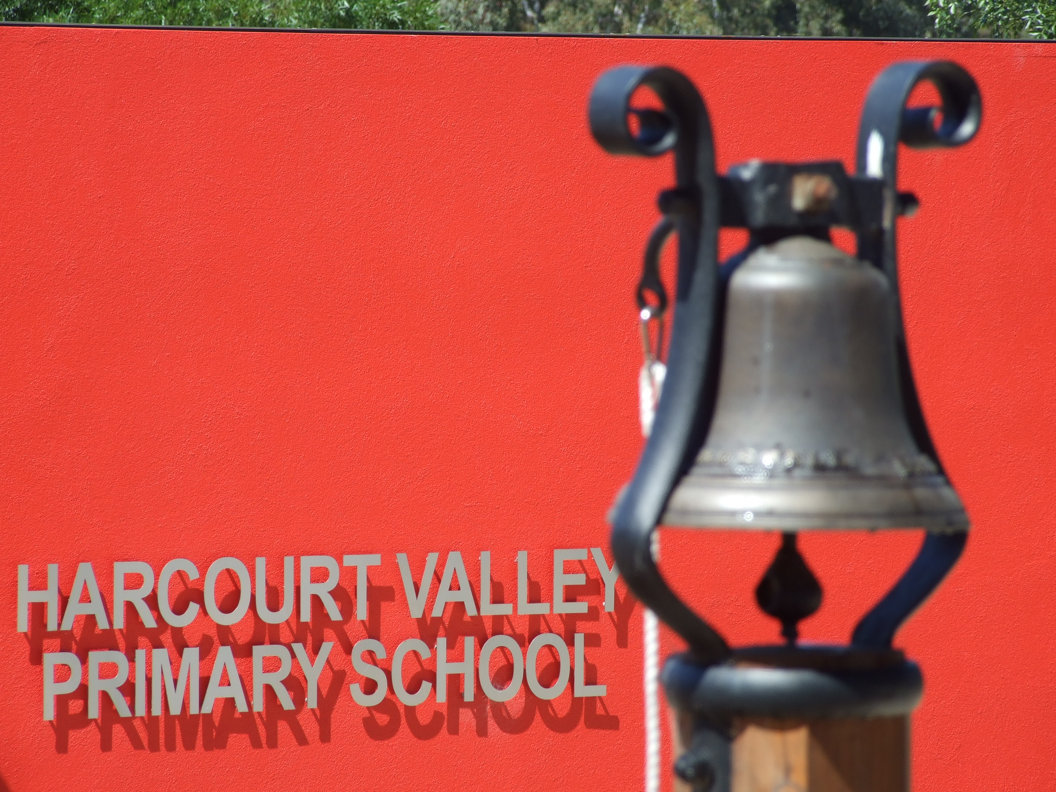
  Annette Smith
  Name of School Principal:
  Jacqueline Cue
  Name of School Council President:
 |  |  |  | 18th March 2015  18/03/2015
  Date of Endorsement:

All Victorian government school teachers meet the registration requirements of the Victorian Institute of Teaching (www.vit.vic.edu.au).

This school meets prescribed minimum standards for registration as regulated by the Victorian Registration and Qualifications Authority (VRQA) in accordance with the Education and Training Reform Act 2006, inclusive of those schools granted an exemption by the VRQA under the 'Student enrolment numbers' and/or 'Curriculum framework for schools - languages program' minimum standards until 31 December 2014.

About Our School

School Context

In 2014, the school enrolment was 73 which fluctuated throughout the year, to end the year in the high 70’s. The SFO was 0.444 which is lower than in previous years. The school buildings were completed in 2009 using the flexible learning spaces model, continue to serve the learning programs very well and good use is made of all spaces. Specialist programs in Visual Arts, Music and French were delivered as in the previous year. The two hour literacy block is well entrenched at all grade levels as is the Maths block. Other school based programs in Physical Education, Library, Arts incursions and the camping program provide a diversity of learning for all students.
The school underwent a school review in 2014 and this has been a valuable activity to redirect the school in its improvement journey. The focus of the new Strategic Plan in the next few years will be on improving both Writing and Maths across the school. A program of classroom observations, additional professional lwearning to build the capacity of teachers and moderation of student work will be the cornerstone of this work.
The school value for this Strategic Plan are Resilience, Respect, Responsibilty and Integrity.
Workforce composition,: This school has 7.27 equivalent full-time staff: 1 Principal class, 8 teachers and 3 Education Support Staff.

Achievement

Overall, students have achieved at the appropriate level in English and this is a similar result to like schools. An additional focus needs to be on learning gain in writing as this has not matched other areas of English. Learning gain in Spelling and Grammar & Punctuation has been higher than state average and this can perhaps be attributed to additional teacher professional learning in these areas. In Maths, levels of achievement are lower than expected.
In order to address the lower scores in Writing, it is planned to undertake additional professional learning for teachers intended to build their capacity to teach writing and also to moderate student writing.
In Maths, additional professional learning to build teacher capacity is planned to be undertaken and also completion of the school’s scope and sequence in Maths. Children who have not made twelve months gain in a year will also have Individual Learning Plans.

Engagement

The levels of attendance in all levels are greater than 91% and in line with similar schools. Attendance issues are monitored regularly by the principal and class teachers follow up with phone calls where there is prolonged absence. An attendance award program is in place and is generally very successful. There are articles in the newsletter about the importance of regular attendance and the impact of non attendance. The issue of late arrival is also a focus of the attendance program.
Student Attitude to School Survey data indicates a slight improvement in 2014. This is most likely linked to the work done through the implementation of Kidsmatter.

Wellbeing

The major focus for the year was the continued development of the Kidsmatter program. Having well embedded the Component 1 of a positive school community, staff undertook training in Component 2 which is Social and Emotional Learning. Following this, staff commenced researching programs and activities to support the implementation of this. Several options were being considered by the end of the school year.
In addition to Kidsmatter, other program which are part of the school’s wellbeing programs have again continued very successfully. These include the Peer Support and Better Buddies program, the camping program, Student Mentoring program and Values Education

Productivity

The school staffing budget was subject to Workforce Bridging Finance in 2014 due to an unexpected withdrawal of children at the end of 2013 and the beginning of 2014. This occurred because the staffing structure had been set in December 2013, with the decision made to continue the successful French program in 2014. The school was staffed on the basis of four classrooms to provide the best possible programs at each grade level. Specialist programs in Art, Music and French provided a diverse curriculum for all students and appropriate time release of all staff. The teaching of grammar and punctuation, the Maths program and the implementation of the Kidsmatter program were the focus of professional development for the year and funds were directed towards this. Planning days were allocated from CRT funds to enable the development of curriculum across the school.

For more detailed information regarding our school please visit our website at
http://www.hvps.vic.edu.au

  Performance Summary
The Government School Performance Summary provides an overview of how this school is performing and how it compares to all other Victorian government schools.

All schools work in partnership with their school community to improve outcomes for children and young people. Sharing this information with parents and the wider school community will foster engagement and collaboration to support further gains and positive learning experiences for all students.

School Profile

School Enrolments

A total of 73 students were enrolled at this school in 2014, 38 female and 35 male.

  Overall socio-economic profile
  Based on the school's Student Family Occupation index which takes into account parents' occupations.
  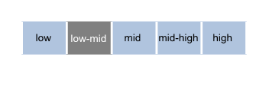
Proportion of students with English as a second language.

  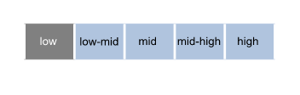
Parent Satisfaction Summary

Average level of parent satisfaction with the school, as derived from the annual Parent Opinion survey. The score is reported on a scale of 1 to 7, where 7 is the highest possible score.

  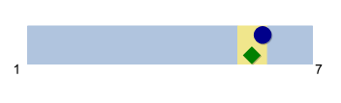
School Staff Survey

Measures the percent endorsement by staff on school climate derived from the annual School Staff survey. The percent endorsement indicates the percent of positive responses (agree or strongly agree) on school climate from staff at the school.
Data are suppressed for schools with fewer than three respondents to the survey for confidentiality reasons.

  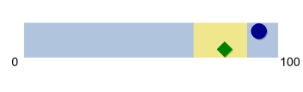

  Performance Summary
  Achievement
  Student Outcomes
  School Comparison
  Teacher assessments from the Australian Curriculum/Victorian Essential Learning Standards (AusVELS)
  Percentage of students in Years Prep to 6 with a grade of C or above in:
  • English
  • Mathematics
  The grades are the same as those used in your child's end of year report.
  A 'C' rating means that a student is at the standard expected at the time of reporting.
  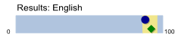
  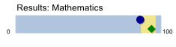
  



NAPLAN Year 3

Average score achieved on the NAPLAN Reading and Numeracy tests conducted in May each year.

Year 3 assessments are reported on a scale from Bands 1-6.

Bands represent different levels of achievement. For Year 3, the National Minimum Standard is at Band 2.

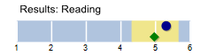
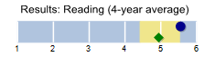
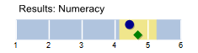
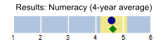

NAPLAN Year 5

Average score achieved on the NAPLAN Reading and Numeracy tests conducted in May each year.

Year 5 assessments are reported on a scale from Bands 3-8.

Bands represent different levels of achievement. For Year 5, the National Minimum Standard is at Band 4.

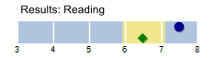
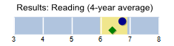
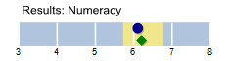
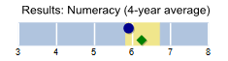

  Performance Summary
  Achievement
  Student Outcomes
  School Comparison
  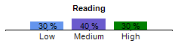
  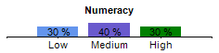
  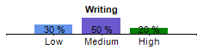
  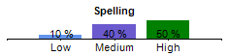
  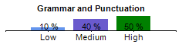
  NAPLAN Learning Gain does not require a School Comparison.
NAPLAN Learning Gain
Year 3 - Year 5

Learning gain of students from Year 3 to Year 5 in the following domains; Reading, Numeracy, Writing, Spelling and Grammar and Punctuation.

NAPLAN learning gain is determined by comparing a student's current year result to the results of all ‘similar’ Victorian students (i.e. students in all sectors in the same year level who had the same score two years prior). If the current year result is in the top 25%, their gain level is categorised as ‘High’, middle 50%, is ‘Medium’ and bottom 25%, is ‘Low’.

  Performance Summary
  Engagement
  Student Outcomes
  School Comparison
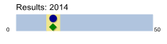
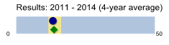
Prep | Yr1 | Yr2 | Yr3 | Yr4 | Yr5 | Yr6
96 % | 91 % | 91 % | 93 % | 92 % | 92 % | 95 %

  Student Attendance
  Average days absent per full time equivalent (FTE) student per year. Common reasons for non-attendance include illness and extended family holidays.
  Absence from school can impact on students’ learning. A school comparison rating of ‘lower’ indicates that the absence rate in this school is greater than what we would estimate, given the background characteristics of their students.
  Average 2014 attendance rate by year level:
  

  Performance Summary
  Wellbeing
  Student Outcomes
  School Comparison
  Students Attitudes to School
  Measures the Connectedness to School factor derived from the Attitudes to School survey completed annually by Victorian government school students in Years 5 to 12. The school's average score is reported here on a scale of 1 to 5, where 5 is the highest possible score.
  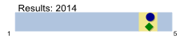
  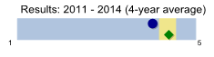
  

  How to read the Performance Summary
  What are student outcomes?
  Student outcomes show the achievements of students in this school in English and Mathematics. They also show results in national literacy and numeracy tests and, for secondary colleges, the Victorian Certificate of Education (VCE) examinations. They provide important information about student attendance and engagement at school.
  For secondary colleges, the Performance Summary also provides information about how many students at this school go on to further studies or full-time work after leaving school.
  You can see these results for the latest year, as well as the average of the last four years (where available).
  The Performance Summary also allows you to compare student outcomes for students at this school with the outcomes of students in all other Victorian government schools.
  What is a School Comparison?
  The School comparison is a way of comparing school performance that takes into account the different student intake characteristics of each school.
  A School comparison takes into account the school’s academic intake, the socio-economic background of students, the number of Indigenous students, the number of non-English speaking and refugee students, the number of students with a disability, and the size and location of the school.
  The School comparison measures show that most schools are doing well and are achieving results that are ‘similar’ to what we would estimate given the background characteristics of their students. Some schools are doing exceptionally well with the students they have, and have ‘higher’ performance. Some schools have ‘lower’ performance after taking into account their students’ characteristics – these schools will receive targeted support to ensure that there is improvement.
 | 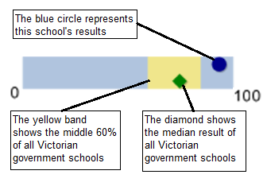
 |  |  |  |  |  |  | 
Looking at both the student outcomes and school
comparisons provides important information about what
a school is doing well and the areas that require further
improvement.

More information on school comparison performance
measures can be found at:
http://www.education.vic.gov.au/school/principals/manage
ment/pages/performreports.aspx

What is the meaning of ‘Data not available’?

For some schools, there are too few students to provide
data. For other schools, there are no students at some
levels, so school comparisons are not possible. Newly
opened schools have only the latest year of data and no
averages from previous years. The Department also
recognises the unique circumstances of Specialist, Select Entry, English Language and Community Schools where
school comparisons are not appropriate.

What is this school doing to improve?

All schools have a plan to improve outcomes for their
students. The ‘About Our School’ statement provides a
summary of this school’s improvement plan.

Additionally, NAPLAN learning gain charts are provided for each of the NAPLAN domains. These compare a student's current year NAPLAN result to the results of all ‘similar’ Victorian students (i.e. students in all sectors in the same year level who had the same NAPLAN score two years prior).

If the current year result is in the top 25% their gain level is categorised as ‘High’, the middle 50% is categorised as ‘Medium’ and the bottom 25% is categorised as ‘Low’.

 |  | 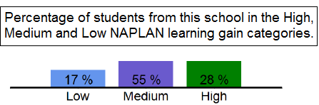

  Financial Performance and Position
  Financial Performance - Operating Statement
  Summary for the year ending 31 December, 2014
  Financial Position as at 31 December, 2014
  Revenue
  Actual
  Funds Available | Actual
  High Yield Investment Account | $7,092
  Official Account | $3,795
  Other Accounts | $12,235
  Total Funds Available | $23,122
  Student Resource Package
  $622,573
Government Provided DE&T Grants | $72,895
Government Grants Commonwealth | $787
Revenue Other | $2,489
Locally Raised Funds | $75,350

  Total Operating Revenue
  $774,095
  Expenditure
  Financial Commitments
  Operating Reserve | $23,122
  Total Financial Commitments | $23,122
  Student Resource Package
  $622,573
Books & Publications | $836
Communication Costs | $3,234
Consumables | $9,646
Miscellaneous Expense | $32,369
Professional Development | $4,126
Property and Equipment Services | $56,264
Salaries & Allowances | $28,649
Trading & Fundraising | $13,797
Travel & Subsistence | $66
Utilities | $13,151

  Total Operating Expenditure
  $784,710
  Net Operating Surplus/-Deficit
  ($10,616)
  Asset Acquisitions
  $0
  Misc Expenses may include Bank charges, Health and Personal Development, Administration charges, Camp/Excursion costs and Taxation charges.
  Salaries and Allowances refers to school-level payroll.
  Financial performance and position commentary
  Financially it was a difficult year in 2014. There was a $6500 deficit which had to be repaid from the previous year and the costs of utilities and other consumables took a significant part of the budget. It was necessary to use some of our investment funds to meet the cost of the deficit. The cost of replacement teachers to cover professional development in addition to illness was higher than in previous years. Fundraising was extremely successful and this enabled School Council to continue to provide additional resources to the school.

