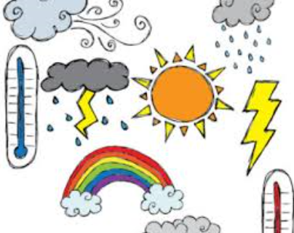
Harcourt Valley Primary School
Curriculum Overview
Grade: Prep/1 Term: 3, 2017
Class Teacher: Mrs Victor-Gordon
Integrated Curriculum Topic for this term: Weather
Literacy  Prep  - Alphabet and sounds  - Reading First 50 Most Used Words  - Spelling First 25 Most Used Words  - Reading and comprehension strategies  - Writing 2-3 sentences using some correct sounds and sight words  - Poetry, recounts, information reports  - Handwriting – formation of the letters and numbers  Grade 1  - Reading First 200 words +  - Spelling First 50 words +  - Reading and comprehension strategies  - Writing Genres - Poetry, Recount, information reports, short stories, opinion writing, editing writing  - Handwriting | Numeracy  Prep  - Skip Counting by 1s, 5s and 10s to 100  - Identifying numbers up to 100  - Ordering numbers to at least 20  - Addition and subtraction to 20  - Counting backwards from 20  - Time – o’clock times on analogue and digital clocks  - 2D and 3D shapes  - Measurement using informal units  - Days of the Week  - Money  Grade 1  - As above but also activities with numbers up to 999 (eg addition, subtraction, ordering)  - Half past, quarter past and quarter to times  - Adding money of same and mixed values  - Months of the Year  - Measurement, Mass and Area  - Graphing
Health & PE  - Skipping  - Coordination and Balance  - Gymnastics  - Tennis  - Scooter Ed  - Sportsmanship and cooperation | Discovery Curriculum  - Weather is different throughout the world  - Seasons  - Weather Forecasts  - Ways and tools used to measure the weather  - Experiments to show different aspects of weather,  - Tornadoes, cyclones, storms, thunder, lightning, floods, fires  - Understanding that weather affects our daily life - clothing, lifestyle, housing etc
Art  - Printmaking  - Colliagraph print of different facial features  - Art of Japanese paper cut-outs called ‘Notan’  - Studying indigenous Australian paintings  - Record different weather patterns  - Building a 3D animal using papier-mache | Music  Students in P/1 will be preparing for the whole school concert with a particular focus on what great performers look, sound and feel like. They will learn 2 songs and dance routines which required musical memory, physical memory and self -discipline. Students learn how to work in a group to achieve the best possible performance that they are capable of.
French
Continuing to build on routines and songs. Finishing off and performing play in small groups. Starting new unit of work, 'Le Petit chat' (The little cat).

